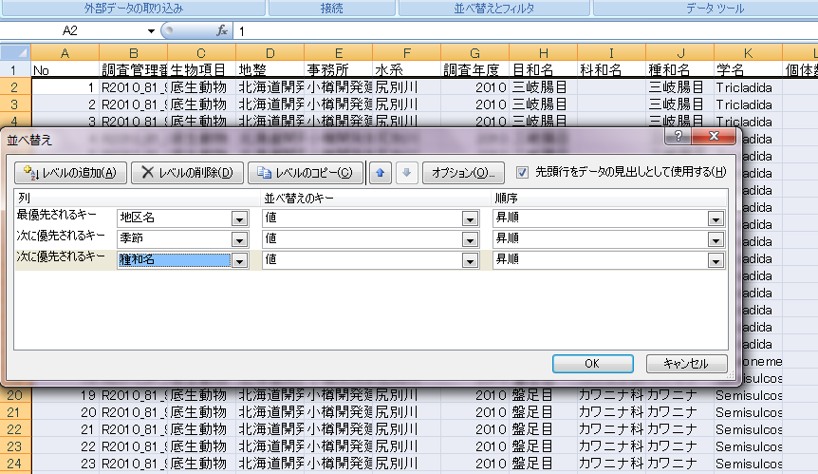
https://www.mlit.go.jp/river/basic_info/jigyo_keikaku/gaiyou/seibi/ishikari_index.html
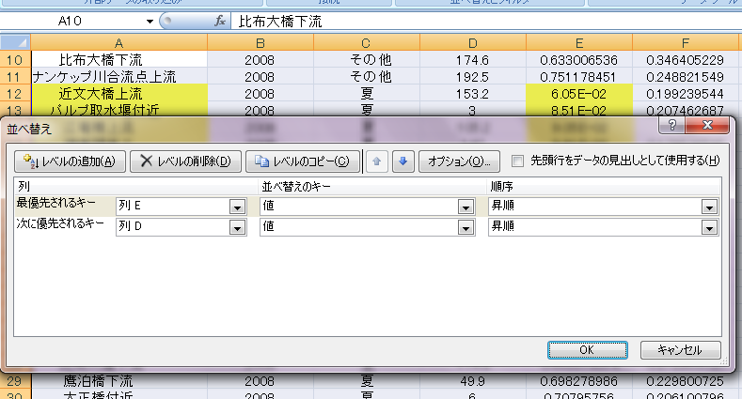
https://www.mlit.go.jp/river/basic_info/jigyo_keikaku/gaiyou/seibi/index.html
http://mizukoku.nilim.go.jp/ksnkankyo/mizukokuweb/system/system.htm

